**Practical 4 Find runner-up from given list**

**GitHub link:** [Python-PIP/20CE140_Prac3_Assignment2.py at main · Dhwani-S/Python-PIP (github.com)](https://github.com/Dhwani-S/Python-PIP/blob/main/Practical%203/20CE140_Prac3_Assignment2.py)

Given the participants' score sheet for your University Sports Day, you are required to find the runner-up score. You are given ***n*** scores. Store them in a list and find the score of the runner-up.

**Input Format:**The first line contains. The second line contains an array A[]  of ***n*** integers each separated by a space.

**Constraints:**

**Output Format:**Print the runner-up score.

**Sample Input**

5

2 3 6 6 5

**Sample Output**

5

**Explanation:**Given list is **[2,3,6,6,5]**. The maximum score is **6**, second maximum is **5**. Hence, we print **5** as the runner-up score.

Code:

#20CE140  
# Dhwani Suthar  
*'''  
Given the participants' score sheet for your University Sports Day, you are required to find the runner-up score. You are given n scores. Store them in a list and find the score of the runner-up.  
Input Format: The first line contains. The second line contains an array A[] of n integers each separated by a space.  
'''*n = int(input("Enter size\n"))  
A = [int(A) for A in input("Enter elements:\t").split()]  
A.sort()  
res =[]  
for i in A:  
 if i not in res:  
 res.append(i)  
print('Runner-up Score: ',res[-2])

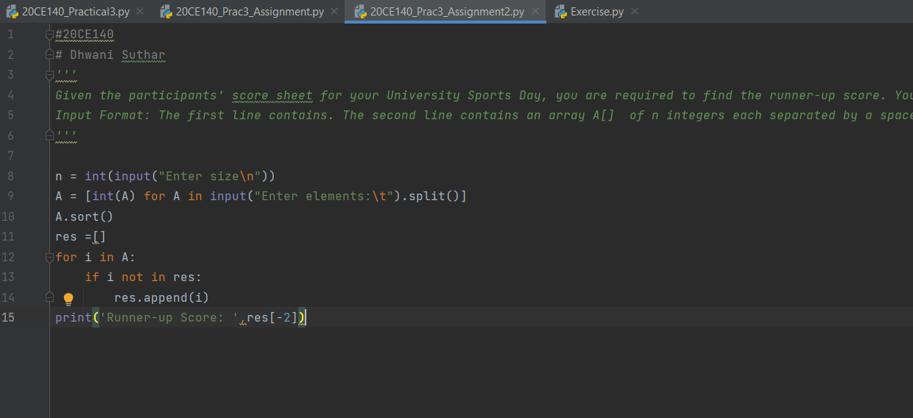

**Output:**

